User Manual

Pixpo Viewer 2.0

Pixpo Technologies Inc

About this manual
Pixpo Viewer 2.0 is our free version of video surveillance software. For viewing your Pixpo IP camera on a Windows based computer. Some features in the software may not be available for you; it’s only available in full-featured Pixpo CMS, which is not covered in this manual. Upgrade options: Similar features shared between Pixpo Viewer and Pixpo CMS, make it easy to upgrade to our premium product Pixpo CMS.

Legal Considerations
Video and audio surveillance can be regulated by laws that vary from country to country. Check the laws in your local region before using this product for surveillance purposes.

Disclaimer
This text is intended for general information purposes only, IP camera is sophisticated network device, it may require networking expertise for propertied setup, and we do not offer step by step setup support.
Pixpo Technologies cannot be held responsible for any technical or typographical errors. Pixpo Technologies makes no warranty of any kind with regard to the material contained within this document, including, but not limited to, the implied warranties of merchantability and fitness for a particular purpose.
Any risk arising from the use of this information rests with the recipient; Pixpo Technologies shall not be liable nor responsible for incidental or consequential damages in connection with the furnishing, performance or use of this material. Pixpo Technologies reserves the right to make changes to the product and documentation without prior notice.
First Time Use

System requirements

Operating System: Microsoft Windows 8 / Windows 7 / Windows XP / Windows 2008
CPU: Intel® Core2™ Duo, minimum 2.4 GHz or higher
Memory: Minimum 1 GB
Graphics Adapter: AGP or PCI-Express, minimum 1024*768

Install the Pixpo Viewer 2.0

The Pixpo Viewer must be installed on a windows based computer before you can use it. Typically, you download the Pixpo Viewer 2.0, and then install it on your computer. You may install the Pixpo Viewer 2.0 from a CD.

Use the software

2.1. The login process

After the software is installed successfully, on your desktop, double-click the Pixpo Viewer Icon to open the Pixpo viewer.
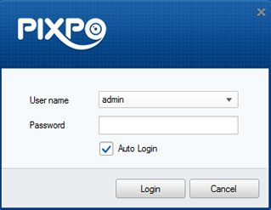
Note: the default password for admin was not set, leave it empty at the first time, you can setup admin password in the user management, after you login the system.
Optionally, check the checkbox Enable Auto-login to log in the software automatically.
Click Login

2.2. Software interface

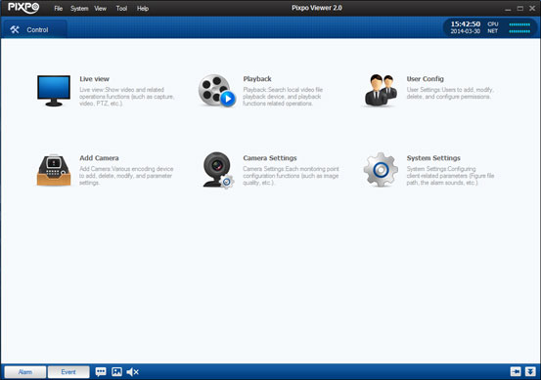

Function Module

Icon | Description
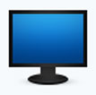 | Live view for real time monitoring. Support manual capture, recording, PTZ control, etc.
 | Video playback for search
 | User management, add, edit and deleting user accounts, set permissions
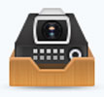 | Add, edit, delete IP camera
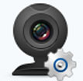 | Camera set up, set IP address, WiFi connection
 | Configuration of general parameters, like file saving path, alarm sounds and other system settings

2.3 Add cameras

In control tab, click add camera module icon. Add camera tab will open up. Please check and make sure your IP camera is connected to the network, before add cameras.

Please note: This software support Pixpo cameras only, third party camera will not support

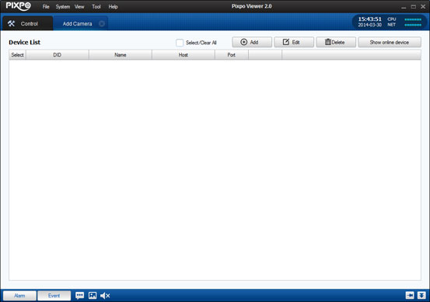

2.3.1 Add IP cameras by using camera ID
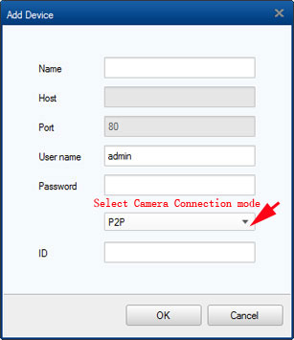
- Click on Add button, bring up Add device screen.
- Create a name for the camera for example: Front Door, put in the name field
- User name, which is the camera’s user name
- Password, camera’s password for above user
- P2P is the default connection method, if not, select P2P
- Type in the camera’s P2P ID number, the camera’s P2P number located under the barcode, looks like PIX-001234-ABCED
- Click on OK to finish add camera
- To view the camera, go Live view tab (access from Control tab or View menu), click camera from device list

2.3.2 Add IP cameras by search online device
If the camera located at the same local network, you also can use camera search function, to discovery and add camera.
- Click on Show online device button, will bring up camera search screen
- Online cameras in the same network will be search and displayed
- Check the camera you need to add
- Click on OK
- To view the camera, go Live view tab (access from Control tab or View menu), click camera from device list

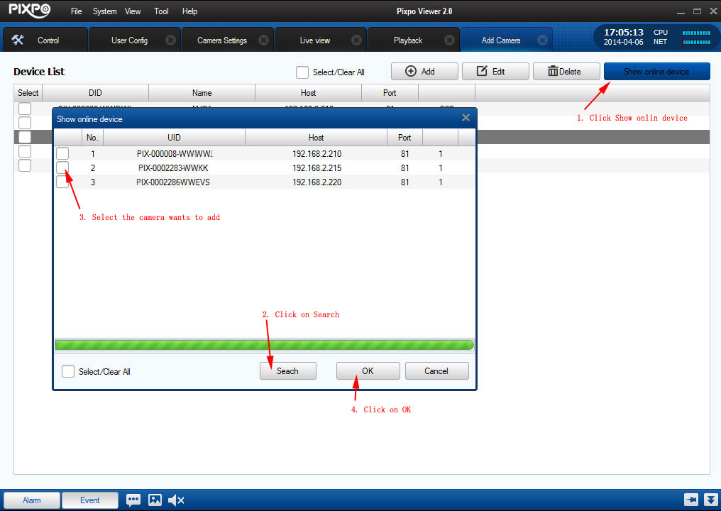

2.3.3 Add IP cameras by IP address (Advanced)
For camera at the same local network, use camera’s IP address connect to the camera will improve the performance, you need assign static IP address to you camera first.
- Select camera connection mode to IP
- Create a name for the camera for example: Front Door, put in the name field
- Host address: the camera’s IP address, like:192.168.1.123
- Port Number：camera’s communication port number, e.g. 80
- Put Camera user name and password, the click OK to connect.
- To view the camera, go Live view tab (access from Control tab or View menu), click camera from device list
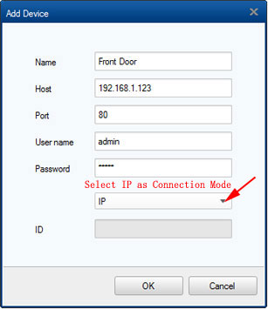

2.3.3 Edit cameras
To modify camera name, camera use name and password, or IP address. Go in to add camera tab, select the camera, then click on Edit

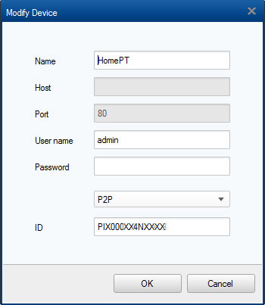

2.4 Live view

To access Live view mode, Click on the live view tab, or click on live view Icon in Control tab. The Live view tab offers you real time view of your security cameras, it also offer different features, including picture capturing, manual recording, PTZ control, etc.
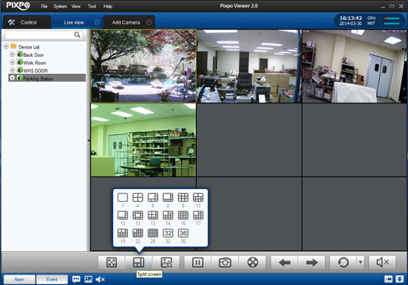
2.4.1 Views

Your IP cameras can be displayed in different view layout, click on the split screen icon to select different view layout. Double click one camera it will enlarge to a single camera view, double click on single camera view, it switches back to multiple camera view.

2.4.2 Add cameras to the View

Once you add camera in Add camera tab, camera will show on left panel Device list, double click the camera to the view. To change the camera view position, just point your mouse to the camera, click and hold left key on your mouse, drag the image to a different position.

2.4.3 Function key (icons)

Icon | Function | Description
 | Full Screen | Display the live view in full screen, press ESC to exit
 | View Pattern | Select different camera layout
 | Digital Zoom | Hold left key on the mouse, drag to area you wants zoom in, HD cameras only
 | Disconnect | Disconnect the camera
 | Snap shot | Take snapshot image for current selected window
 | Manual Recording | Start or stop recording on current selected window
 | Page up/ Down | Change preview pages
 | Rotation | Start stop rotation
 | Volume control | Mute or turn on the Audio in live view

In live view window, right click can bring up following tools menu

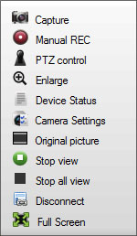

Icon | Function | Description
 | Snapshot | Take a snapshot picture on current active window
 | Start stop manual recording | Start / stop the manual record current channel on the PC
 | Enable or disable audio | Enable or disable audio
 | PTZ Control | Control current widow PTZ camera
 | Digital zoom | Enable the digital zoom function, click again to disable
 | Device Status | Display device status
 | Camera settings | Bring up camera setting tab
 | Stop preview | Stop and start preview
 | Disconnect | Disconnect the IP camera
 | Full screen | Enter and exit full screen mode

2.5 PTZ Control

The software provides PTZ control for cameras with pan/tilt/zoom functionality. You can set the preset, patrol and pattern for the cameras on the PTZ Control panel. And you can also open window PTZ control for the operations of PTZ cameras.

2.5.1 Open PTZ Control

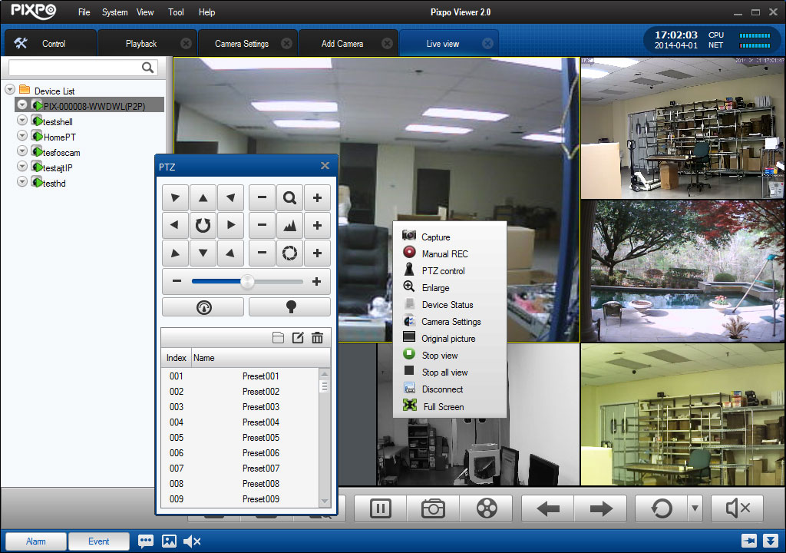

Select active camera, right click the mouse will bring up the menu, select PTZ control, will bring up PTZ control

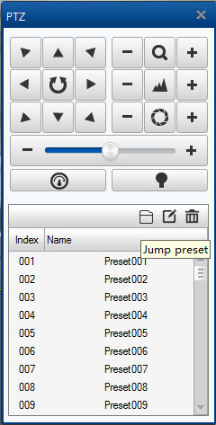

2.5.2 Adjust the image

In live view tab, move the mouse cursor to the bottom of the camera image, will display a control bar, select image setting to bring up adjust screen, adjust color and brightness. Most time those don’t need make changes.
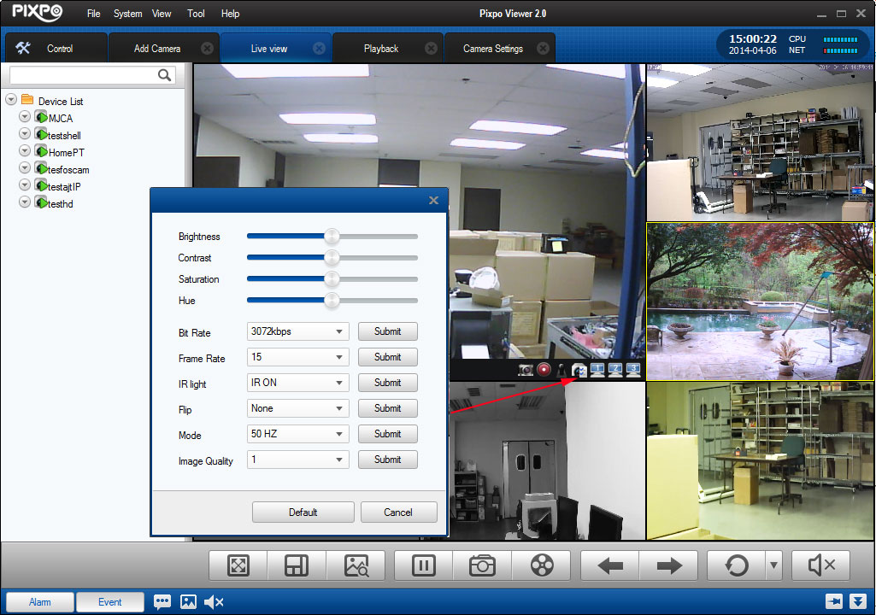

2.6 Recording on local PC

2.6.1 Set video storage location

Camera can be recorded on local PC, performs as a NVR installed on the PC. To set storage location, In control tab, click on System Settings, click on file in left panel, select REC save path, and then click Save.
You can set recording length at this screen, default setting is 10 minutes, and the system will pack 10 minutes recording into one file.

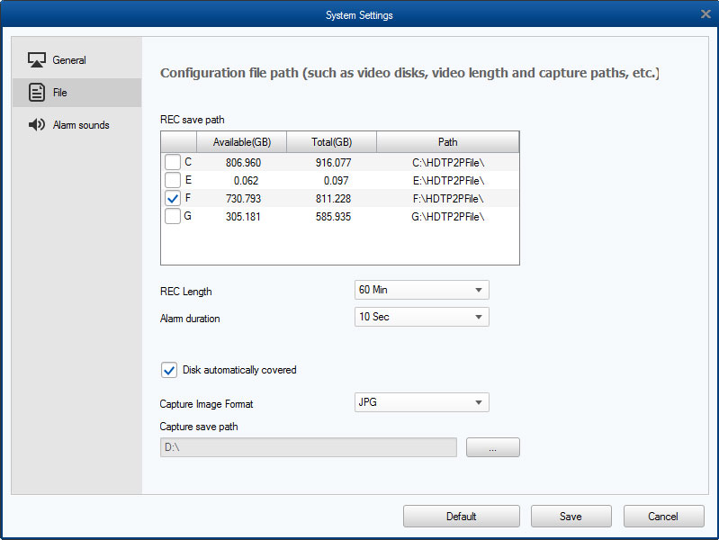

2.6.2 Configuring record schedule

In camera settings tab, select camera from Equipment pulls down manual. Check Enable scheduled recording

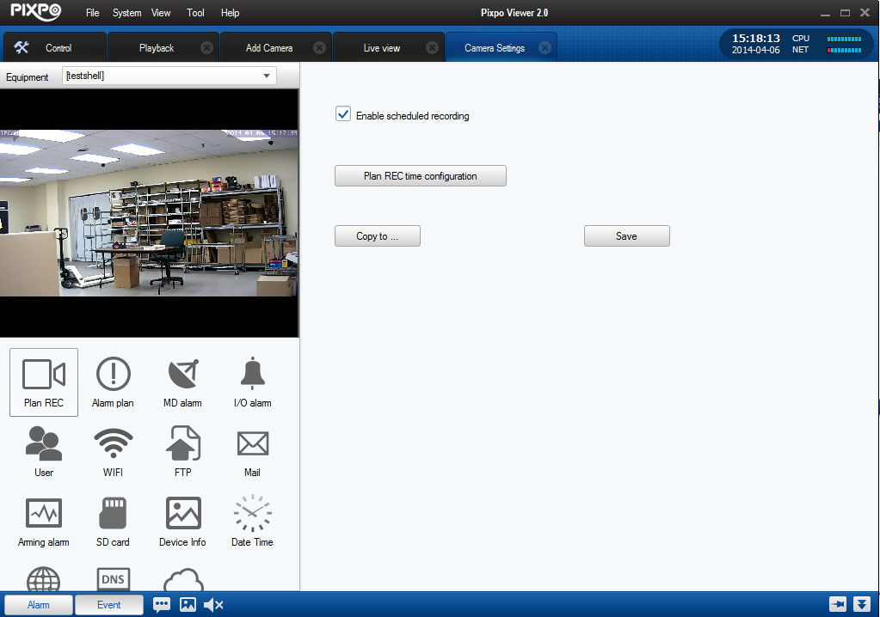

Click Plan REC time configuration

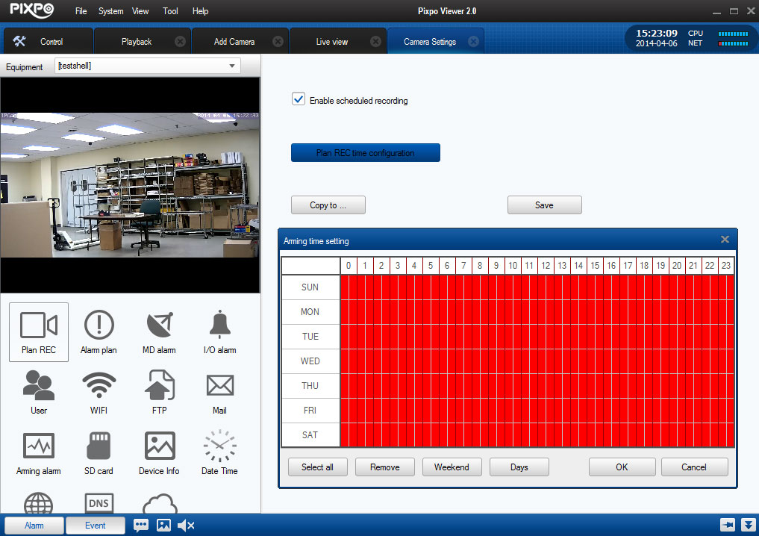

Click Select all, will be recording 24 hours, 7 days a week. If some time don’t need record, use your mouse right key drag on selected time, it turn white

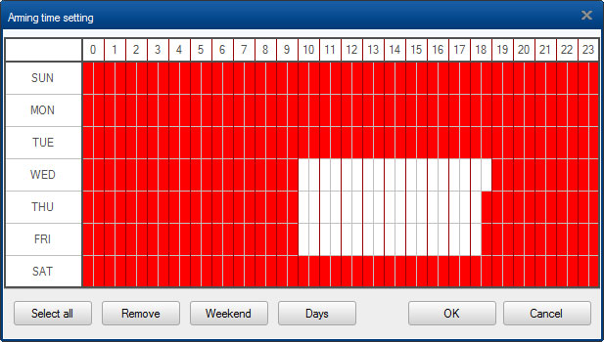

2.6.3 Manual recording

Manual recording function allows you to record the live video on the live view mode, and the recorded files are storage in local PC
Click on manual recording icon to start manual recording 。 If the camera has scheduled recording, system will stop the recording schedule, and record.
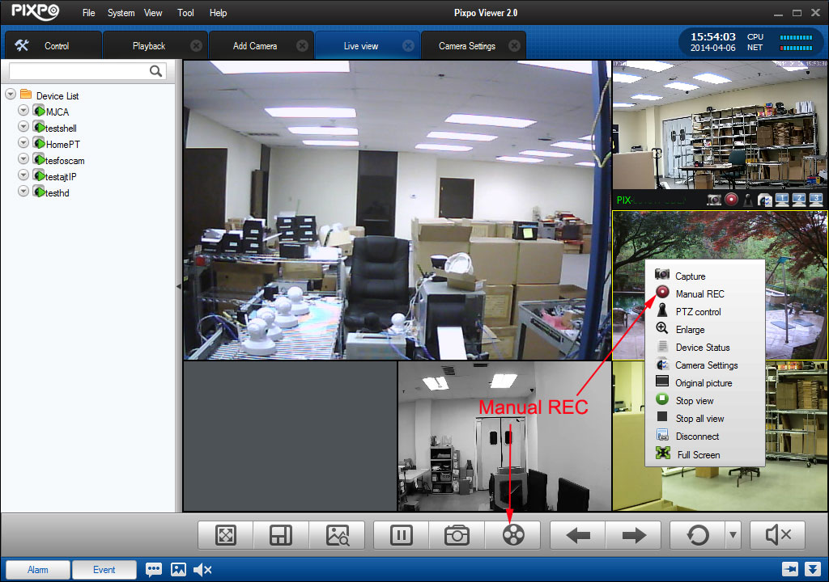

2.7 Enable alarm linkage

2.7.1 Enable the alarm linkage

In camera setting tab, select camera, then click on Alarm plan. Check Enable alarm linkage, click on Aiming time configuration button, to set the schedule.

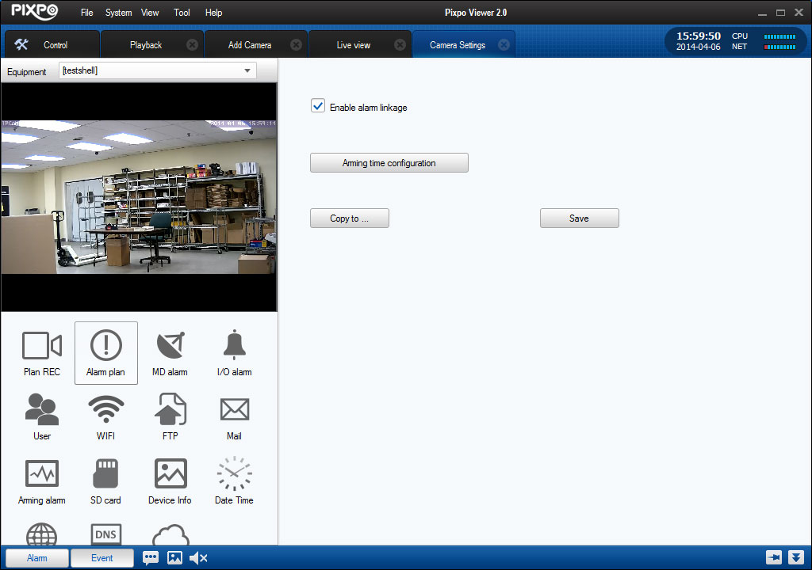
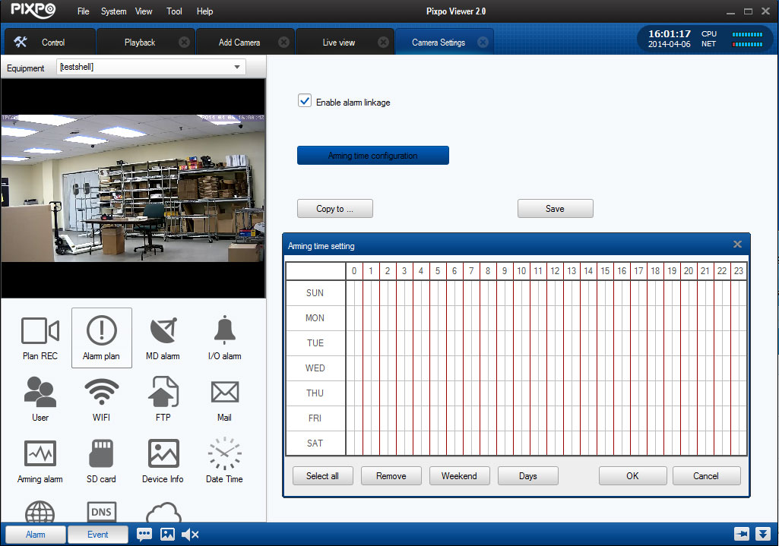

2.7.2 Alarm type
【MD alarm】 Camera start motion detection mode
【I/O alarm】 Enable alarm IO

